**Please find attached a list with some Hotels recommendation in Prague closely located to the congress venue.**

[**Ariston**](http://www.hotelaristonpatioprague.cz/?lang=en)**\*\*\*\* (**[**http://www.hotelaristonpatioprague.cz/**](http://www.hotelaristonpatioprague.cz/)**)**

Recently reconstructed Hotel Ariston & Ariston Patio Prague is situated in the surroundings of the old Zizkov – Prague 3, in buildings from the end of the 19th century. Family atmosphere is characteristic for this hotel; its location not far from the business and historical center of Prague is also convenient. Tram stop in the proximity of the hotel. The main train station only 5 minutes from the hotel.

Distance to congress venue: By foot circa 600m.

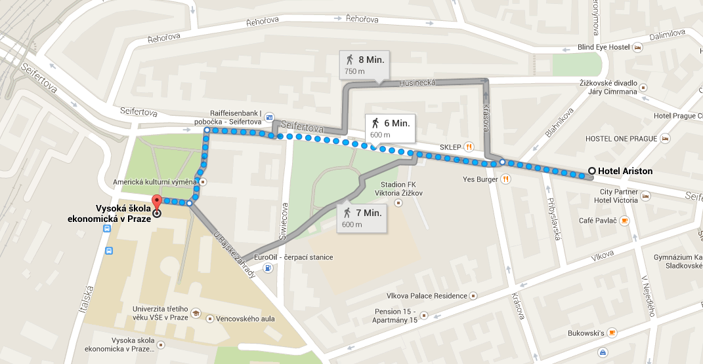

[**Theatrino**](http://www.booking.com/hotel/cz/amedia.cs.html)**\*\*\*\* (**[**http://www.hoteltheatrino.cz/de/**](http://www.hoteltheatrino.cz/de/)**)**

A beautifully constructed „design hotel“ in an art nouveau building. For those enjoy dramatic arts and a theatrical atmosphere, this is the perfect hotel. Decades ago, this building was a theatre complex. Today, it is an architectural gem that stands to remind of Prague’s glorious past. It is classified as a historical building, but was carefully renovated, with modern comforts and conveniences throughout. 73 rooms in a revitalized Art Nouveau theatre classified as a historical building. The hotel has a sauna and a steam-bath. Location: Central located in the art district of Zizkov, 3 stops by street tram or 15 minutes walking distance to the Old Town Square.

Distance to congress venue: 1 km on foot and by tram (No. 5, 9, 20, 26, 55, 58) every 3 minutes.

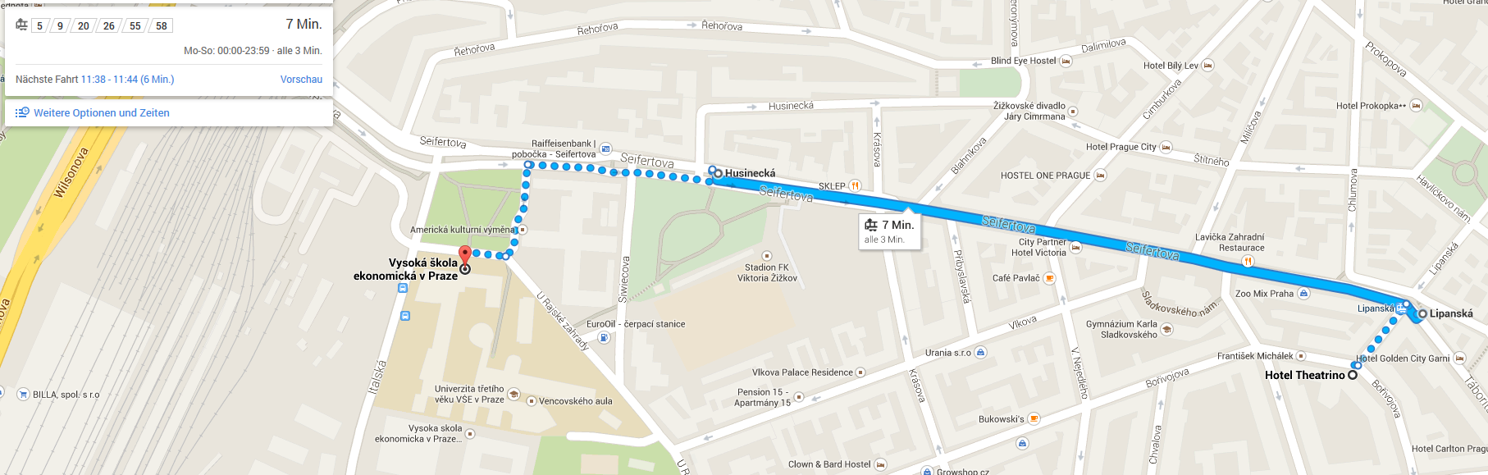

[**Hotel Carlton**](http://www.hotelcarltonprague.cz/)**\*\*\*\* (**[**http://www.hotelcarltonprague.cz/**](http://www.hotelcarltonprague.cz/)**)**

Elegant, completely reconstructed Hotel Carlton is situated in the traditional residential area of the old Zizkov – Prague 3. Hotel is characteristic by its convenient position, not far from the business and historical centre of Prague. A tram stop is in the close proximity of the hotel; the main train station and the underground line C only 7 minutes from the property. Hotel disposes of 48 elegant, stylish and comfortably furnished rooms with air-conditioning, satellite LCD TV, and direct dial phone. In each room is also a minibar, coffee and tea making facilities, safe and PC ethernet connection. There is also available room for disabled guests.

Distance to congress venue: 1.1 km on foot and by tram (No. 5, 9, 20, 26, 55, 58) every 3 minutes.

